PRODUCT DESIGN
Project: Locate a Doctor
Team: Error By Night

Revision History
Revision Number | Date | Summary of Changes | Author(s)
1.0 | 02-19-2024 |  | Error By Night

Class Diagram

- User - This class describes system users who have successfully registered. It contains basic user information such as userId, username, password, email, and user Type (one of patient, doctor, or admin). There are also methods for finding out user details within this class.
- Doctor - This is a class which is used to keep track of Doctors. How to identify them if identified willcase symptoms on it is used to achieve most of fact that the doctor patient has taken class. Also including is available data who is doing worse then normal. It has an access point for symptoms-based predictions and methods to get doctor details.
- Symptom Prediction - This class stores predictions that are generated from symptoms entered by users. It includes attributes such as symptom Id, symptom Name, prediction (predicted disease name), Precaution(s) we had given (recommended precautions), and doctor Category (category of doctor whom to consult).
- Appointment - Represents the appointments a user has made with doctors. Fields include: appointmentId, userId (patient ID), doctorId (The doctor's primary key), appointmentDate, and mode args (0 is virtual or physical). Users can use a class to book an appointment, and there is a method that provides information on specific appointment.
- Feedback - This class is responsible for managing user feedback. feedbackId,userId and feedbackMessage are stored in it. Using this class, users are capable of creating feedback about their grooming experiences through the use of a method.
- PatientRecords: This class is responsible for managing patient records by doctors. DoctorId, PatientId,AppointmentId, diagnosis, treatment, daterecorded will be stored in it.Using this class the, the user can add the record of patient in which the patient is attending the appointment.
Relationship between the classes
Login --> Registration: This association suggests a user should log in before proceeding. Where there is no account, a register option will be offered to him.
User --> Login: This link alone shows that this was a user with an existing user information object before being authenticated. The information of users is used to validate the user in login procedure as user data should be had to make login initial.
Symptom Prediction --> User: The symptoms of the user, recorded in the user’s User Information object are promised along with their interpretation of these predictions. Users make predictions on symptoms to keep records and also analyze information which is shared with other users' accounts.
Appointment --> User: The fact that these links are there shows not only how the information of appointments is related but how it is connected with individual accounts. People can book a visit or apply for a doctor's appointment, in their own names. Details like this, when do they go to this place for what reason--and other data that the doctors may need are seen in their records.
Doctor --> Appointment: Correlation shows that the patient site refers to both the doctors’ profiles and appointment details. Patients are listed in a database as users of the ordinary and new doctors' appointments. The details as to when, where and for what purpose as well as other parameters are accessible to the doctors in their profiles when needed.
Feedback --> Doctor: This link shows there exists an association between feedback supplied by people and given doctors. User may post comments which refer to his or her contacts with a clinician whose tribe is on the site.
Doctor Category --> Doctor: Doctors were included in unique categories, such as specialties, through this. Each and every doctor is a member of (or in some cases heads) his own organization, as well as one she specialized in according to the information and theories she understands.
Pin Code --> Doctor: To link doctors to codes being pins, which means they live around certain pin codes in the area where they reside. A picture involving a doctor in various pin codes and specific sites is drawn as users will be able to choose doctors according to their locations.
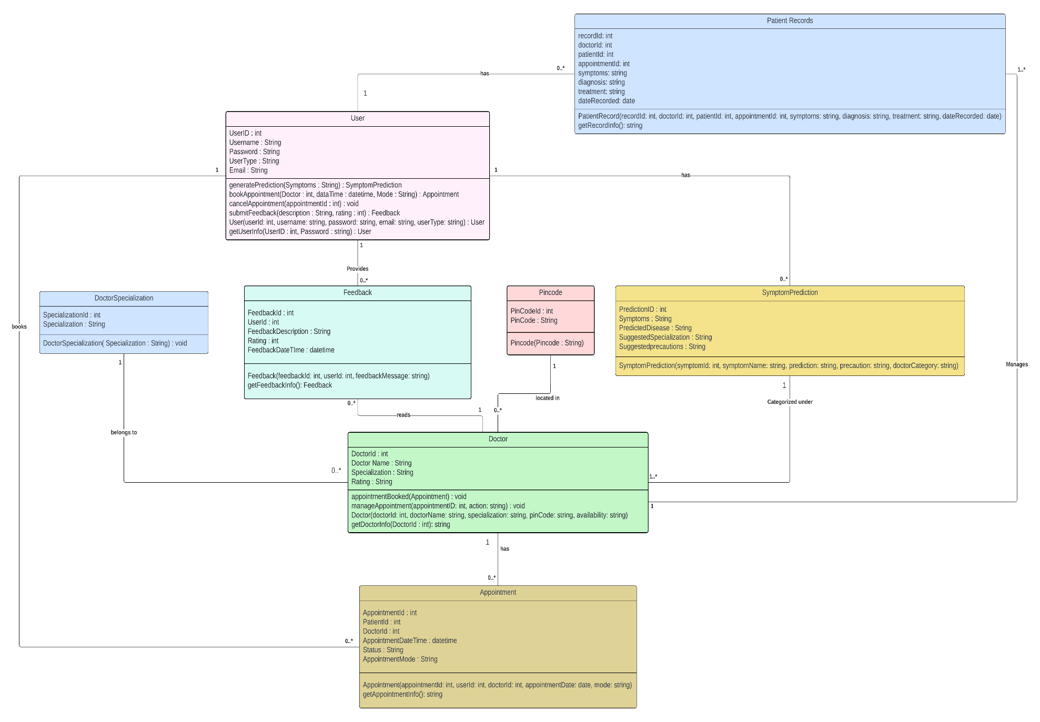

ER Diagram(s)
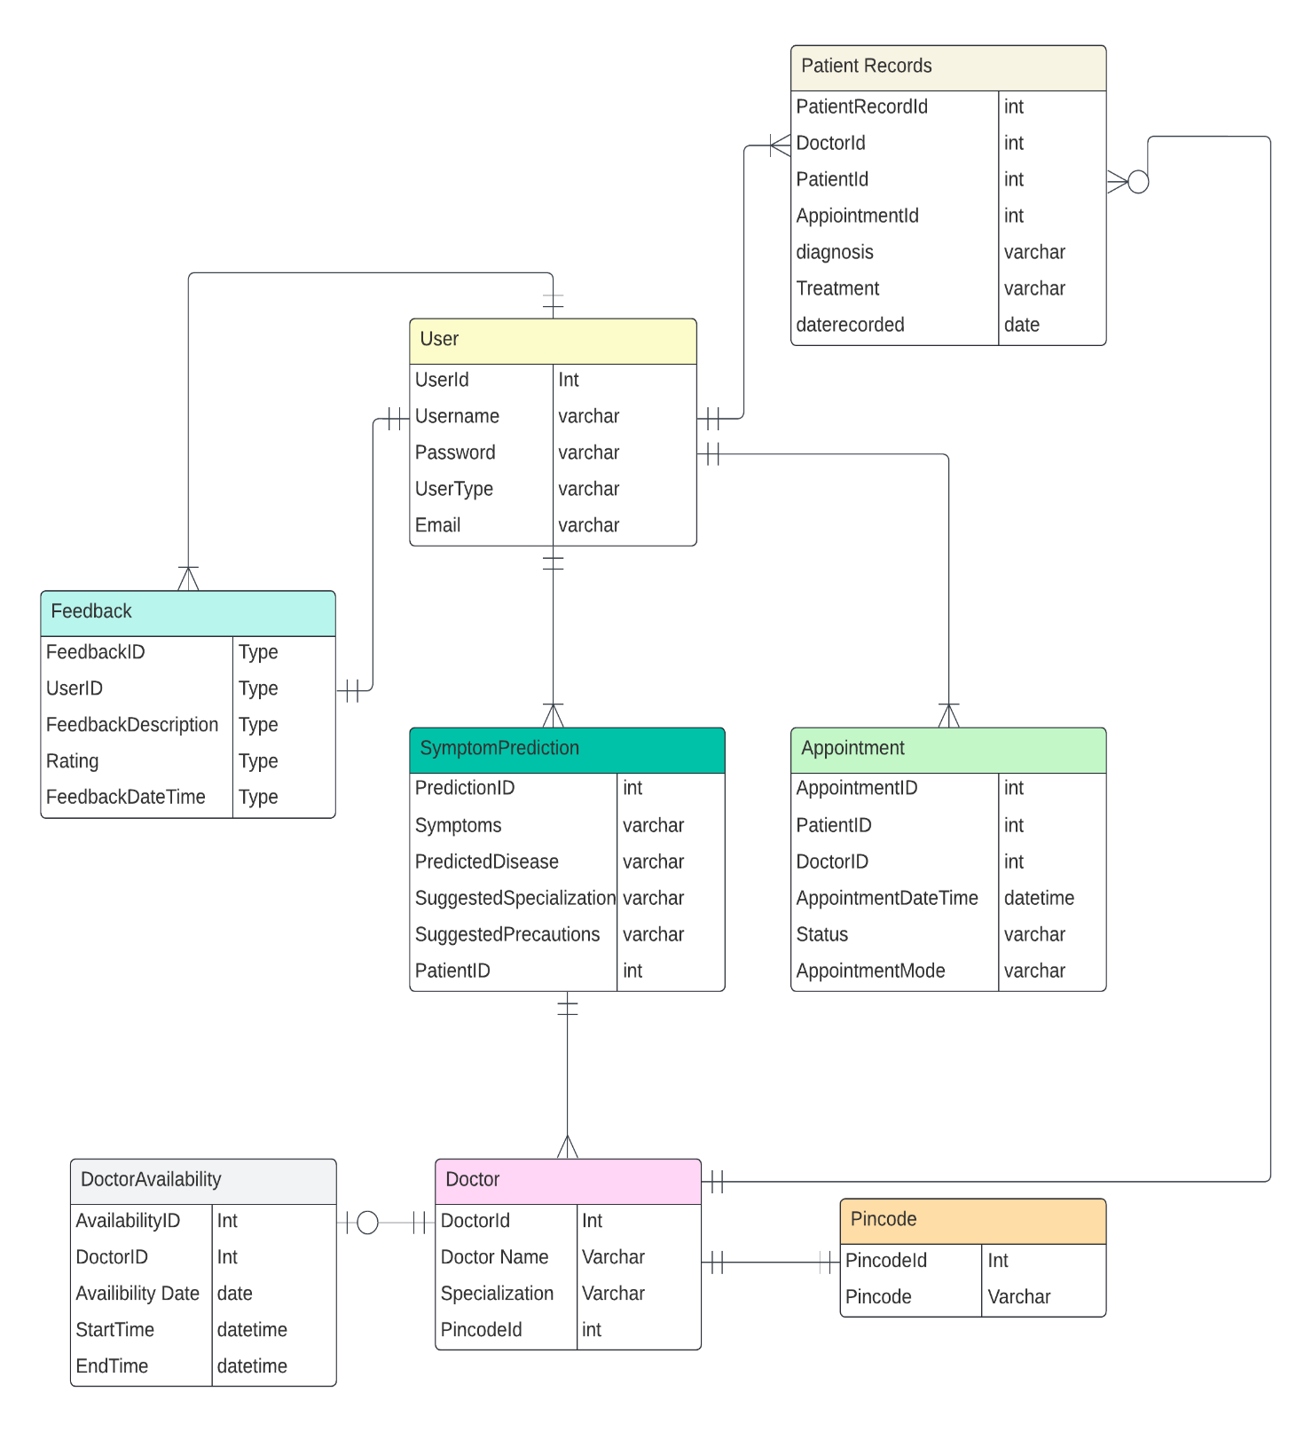

Sequence Diagram(s)

User Registration
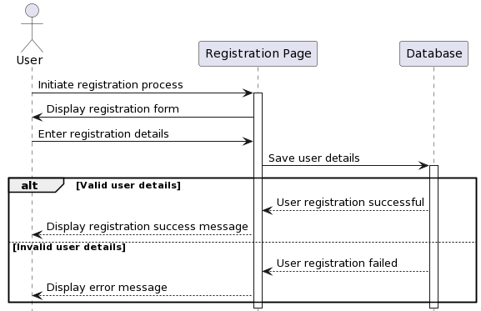

User Login
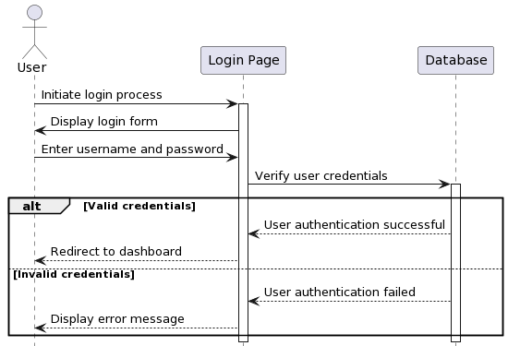

Symptom Input and Prediction
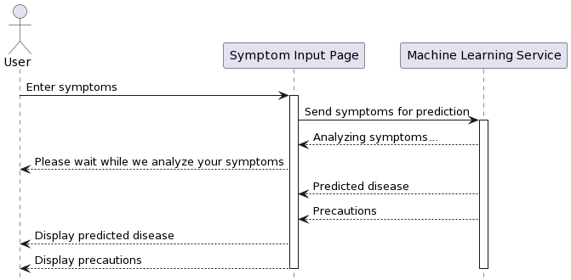

Appointment Booking
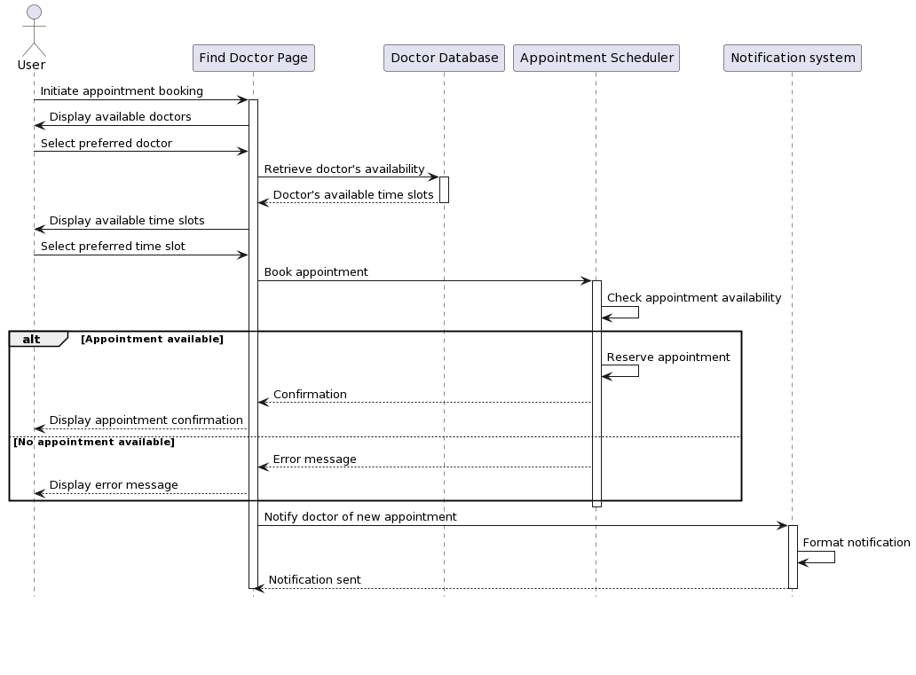

Doctor Search
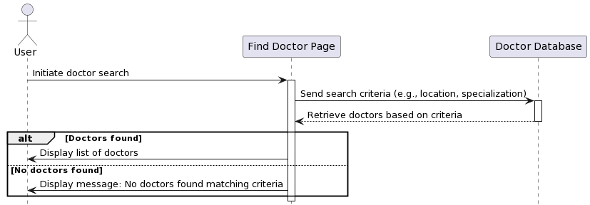

Feedback Submission
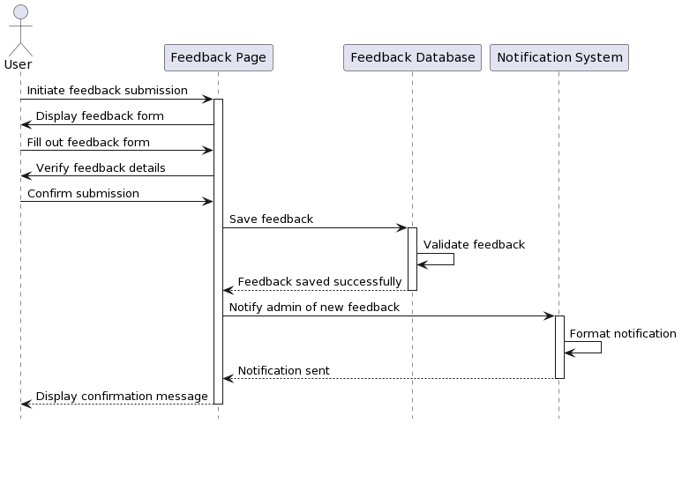

Patient Record Management
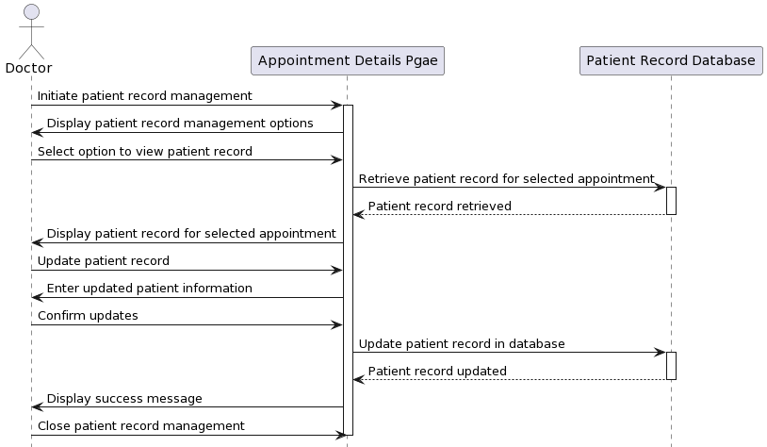

Admin Operations
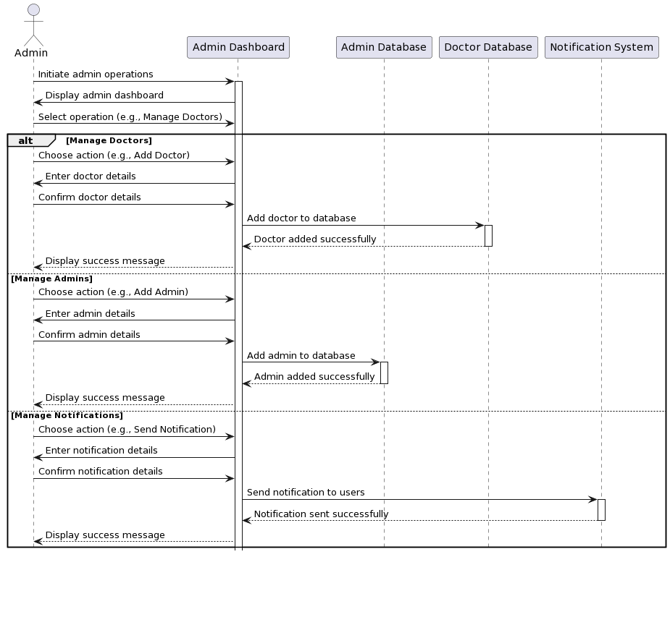

Reports Generation
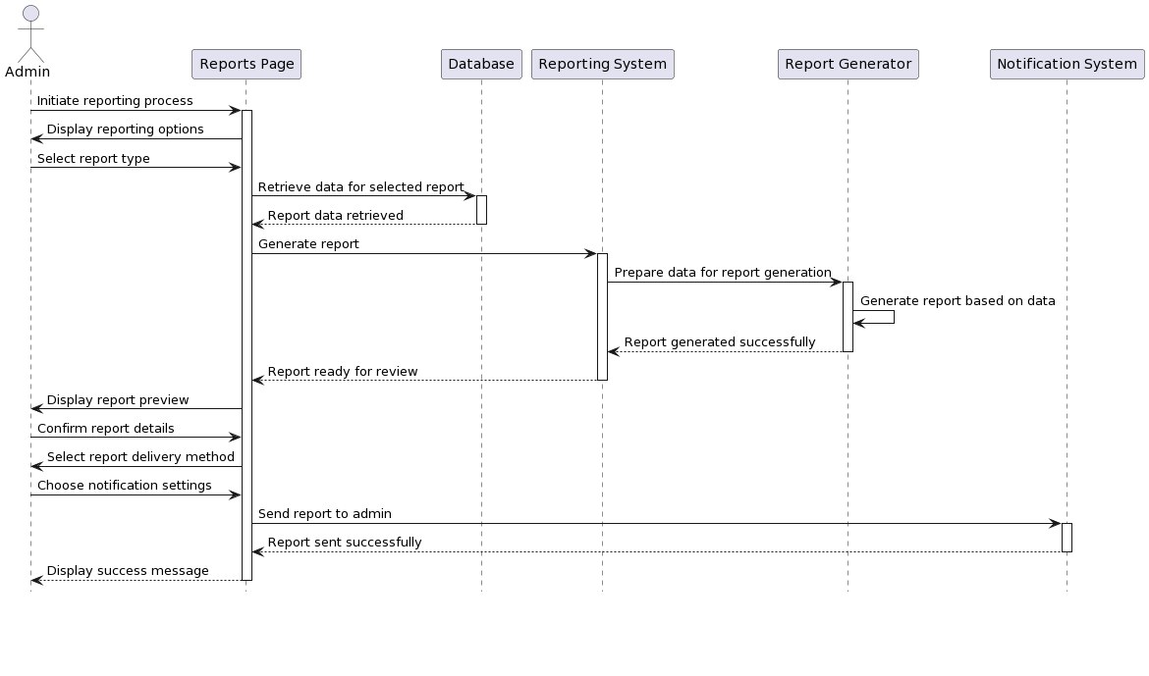

Trend Analysis
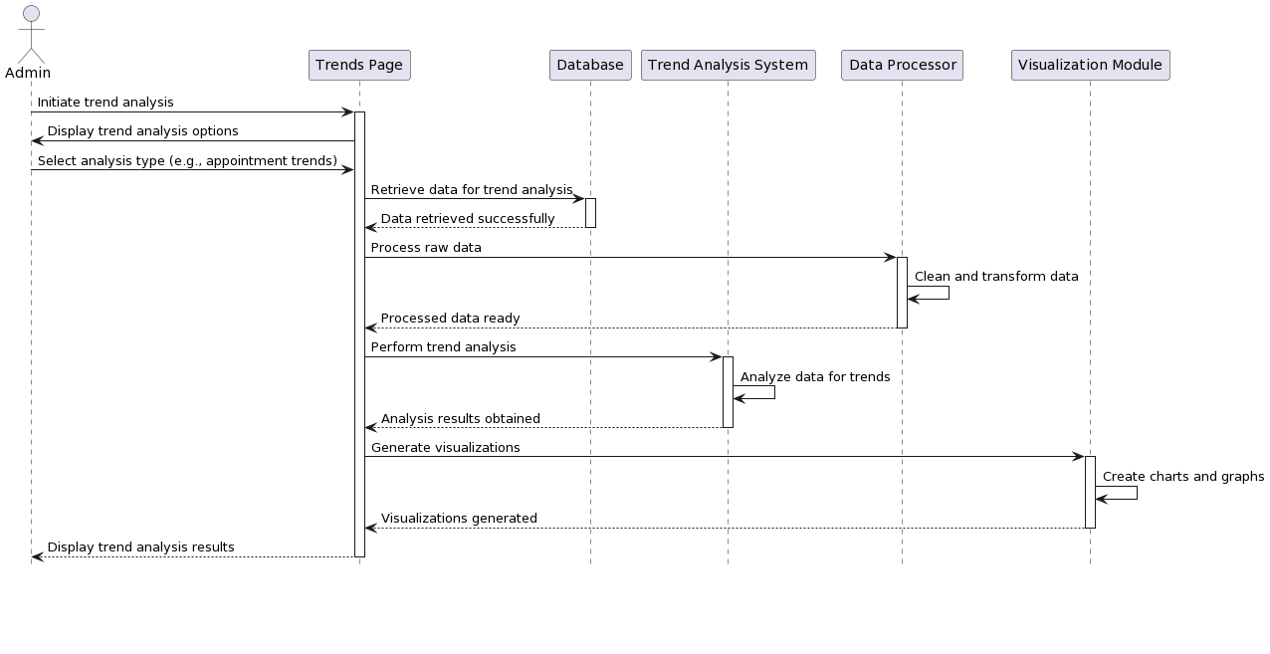

Design Rationale

Reasons for "Find a Doctor": Making it easier for patients to choose doctors and book appointments; Giving doctors tools to manage appointments and patient records; managing it on the system administrator's back end.
Patient:
Patients who use the "Find a Doctor" system get: complete products and services that smooth the way forward in their patient journey as much as possible. The patient experience begins at the time of registration when patients answer a comprehensive questionnaire with a large amount of personal information. It requires everything from their medical history and a list of known allergies to the details of all prior treatment. And it will help assess patient needs accurately, making it possible to give everyone truly personalized treatment.
After successfully registering, patients are directed to a dynamic dashboard tailored to their specific healthcare needs. The dashboard functions as a centralized platform, providing easy navigation and access to a variety of features. Patients can easily input their symptoms, and natural language processing and machine learning algorithms are used to provide accurate disease predictions and precautions.
The doctor search function of the system enables patients to quiz the sizeable health care provider database by specialty, location, and patient ratings. Detailed profiles of physicians offer details of their qualifications, job experience, and patient ratings--helping patients sift through the noise and make informed decisions when selecting a care.
In the platform, appointment booking is just as all for the patients so that they can plan doctor visits on the dates and times they prefer. Patients can now check real-time availability status before fixing an appointment, as well as make letters your appointment date--or earlier. It's simple to modify if the doctor's no go. Rescheduling and canceling appointments used to be hard before. With our appointment management tools you could hardly get a more flexible arrangement than this.
The system eases access to medical records by allowing patients to review their previous medical history, including diagnosis and treatment and prescriptions. Patients can manage their own health information in a secure manner and see to continuity of care and making informed decisions in medical consultations.
Feedback from patients is essential for improving service quality and satisfaction. Patients are invited to write feedback based on their healthcare experiences, such as interactions with front desk clerks, treatment results and overall service quality. This feedback loop enables health care providers to respond to patient complaints, improve quality and promote a patient-centered care approach.
Doctor
Using the "Locate a doctor" system, doctors benefit from a comprehensive suite of practice management tools that are designed to make life easier. When doctors log in, they are greeted by an individualised "dashboard" which includes all kinds of important information about their schedule. The dashboard is also a control centre. It makes essential functions easy to reach.
Appointment management tools allow doctors to control their schedules. They can confirm or postpone appointments with ease, and keep their patients moving in an optimal way. A seamless integration with the system's calendar ensures exact scheduling and timely reminders for upcoming appointments. Doctors can consult detailed patient profiles, complete with personal medical history, diagnoses and treatment plans. This will enable them to make better decisions during consultations.
Doctors will be able to reply to questions that patients ask on secure channels. Doctors can also share follow-up instructions with patients, along with critical health information. Multidisciplinary care coordination and patient outcomes can be improved when physicians work with colleagues and specialists.
The system's feedback mechanism gives doctors many important insights into their patients' experiences with healthcare. Patients can offer feedback on appointment interactions, treatment outcomes and overall satisfaction. This allows doctors to identify service delivery problems and make improvements.
Administrator
The "Locate a Doctor" system is under the control of administrators who are in charge of its operation, maintenance and strategic development. This includes managing user accounts, setting up systems, and optimizing performance.
In addition to the administrator’s tasks, the management of user accounts is another major issue. Administrators ensure data accuracy as well as system security by checking user information and access permissions. They also enforce authentication protocols.
Another crucial duty in the capacity of an administrator is system configuration. In response to user feedback, administrators contact stakeholders on how to upgrade systems, and they also install software updates so as to improve them.
To tailor to the needs of organizations system configuration is one of the most crucial tasks administrators face. They set up operating systems, user interfaces and business processes.
Administrators optimize system performance by observing system performance metrics and identifying hurdles, to work out the most efficient, and reliable solution.
Administrators use reporting and analytical tools to determine system usage patterns, spot trends and make data-supported decisions that improve user experience while increasing operational efficiency.
Administrators have a duty to assure: 1) Compliance with healthcare regulations, privacy laws and industry standards is practiced 2) Data is secured; periodic audits are held; users receive regular training to improve their understanding of and compliance with legal requirements.
On the whole, administrators play a critical role in driving the 'Find a Doctor' continuous improvement and evolution. They must make sure that it integrates with organizational objectives, user experience and industry standards.

Information Architecture Diagram

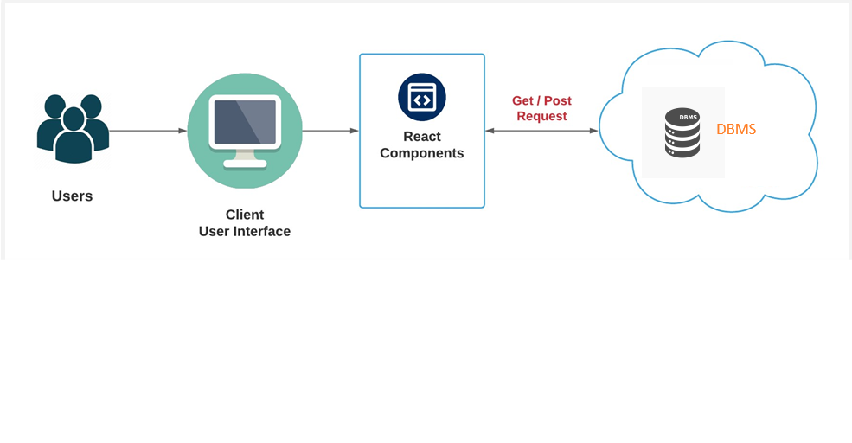

User Interface Wireframe(s)/Screenshot(s)

Color


Stylesheet
We are going to use Bootstrap to style the UI.

Logo
This is the logo that represents Locate a doctor website.

Main Page
This is the main page that the user is returned to when he opens the Locate a doctor.

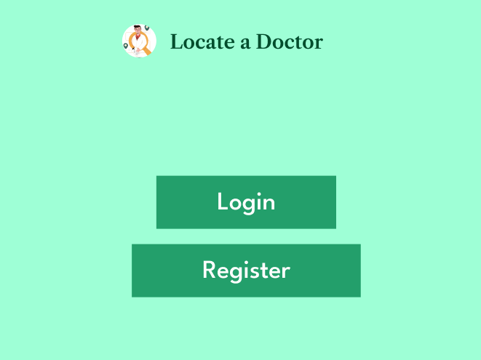

Registration Page
This page allows patients to register for our portal.
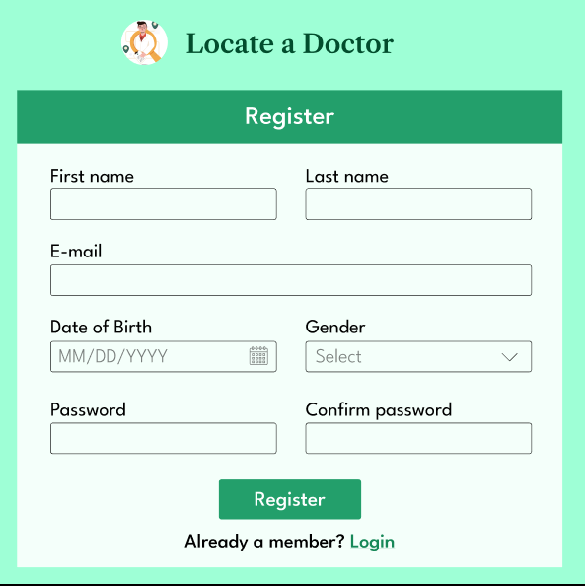

Login Page
This page is an entry page for the portal that requires user identification.
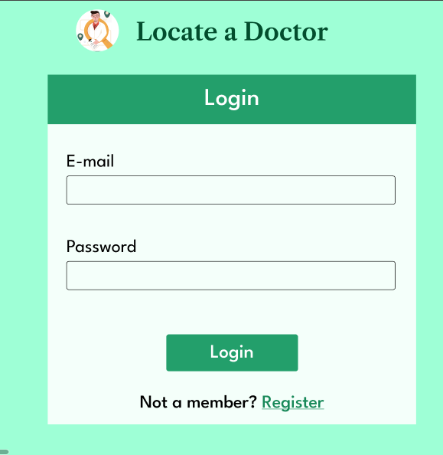

Doctor – Dashboard
This page serves as the dashboard for a logged-in doctor. It will provide him with an overview of his scheduled appointments.
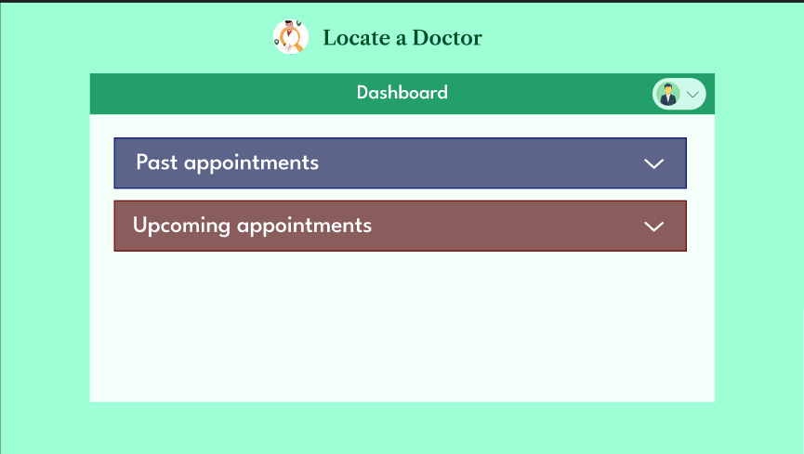

Patient -Dashboard
This page serves as the dashboard for a logged-in patient. It will provide him with an overview of his scheduled appointments
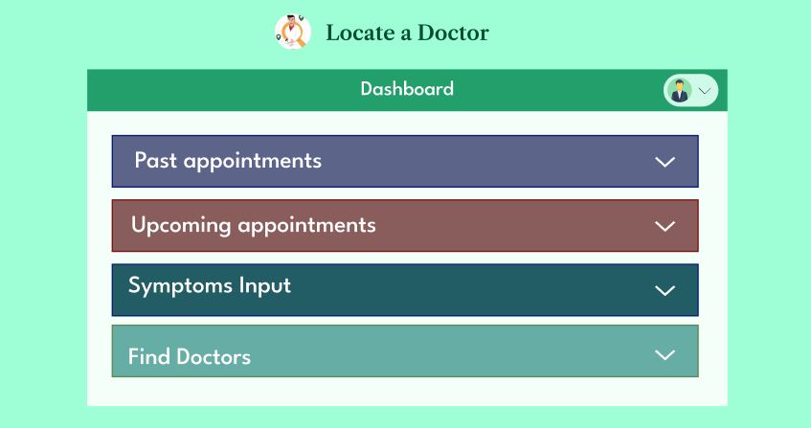

Symptoms input
This page is used to record the symptoms that the patient is experiencing. So that the system can determine which specialist he should consult.
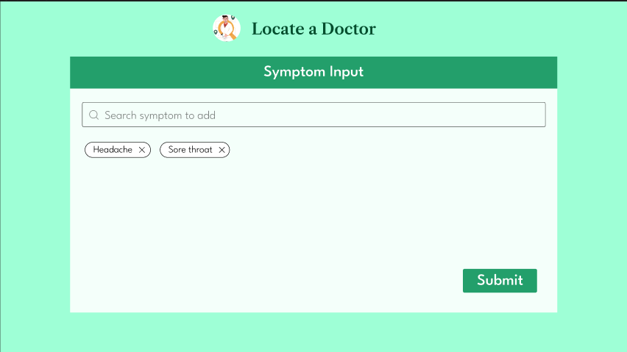

Post Symptoms input
The user will be loaded with this after inputting the symptoms he is suffering from and before predicting the precautions and suggesting the doctor's specialization.
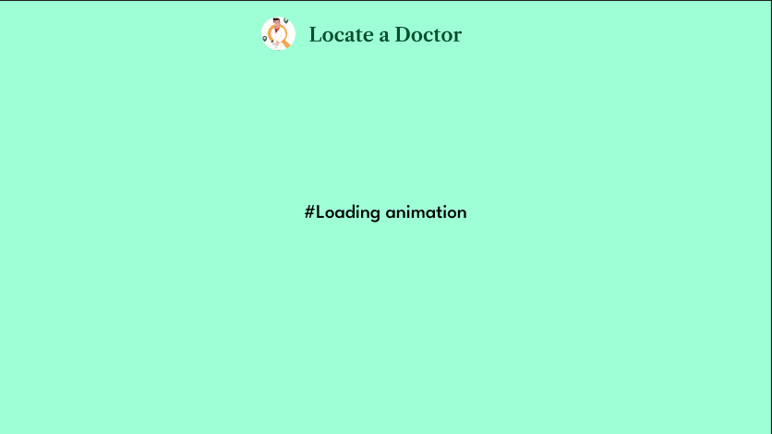

Suggesting the Precautions
This page will be accessed by the patient, and it will display the precautions that he needed to take, as well as the type of specialization that the patient needs to consult with.
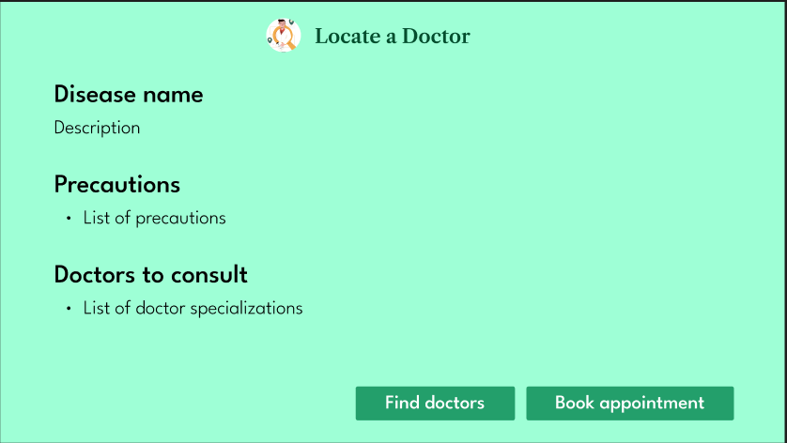

Doctors Finder
This page will be used by patients to find doctors based on the specialization they want to consult with.
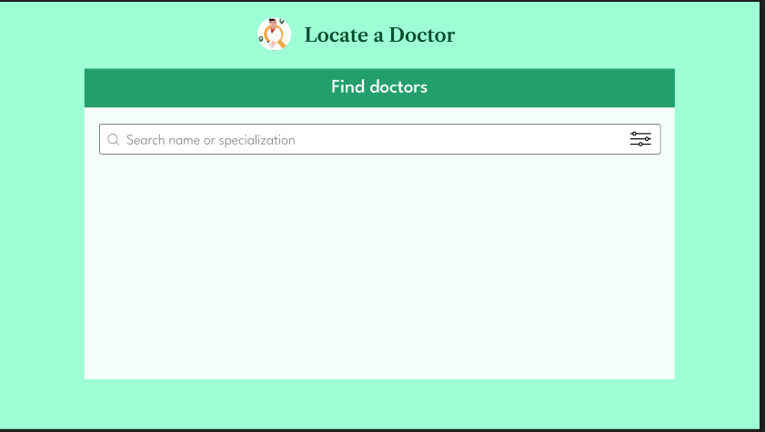
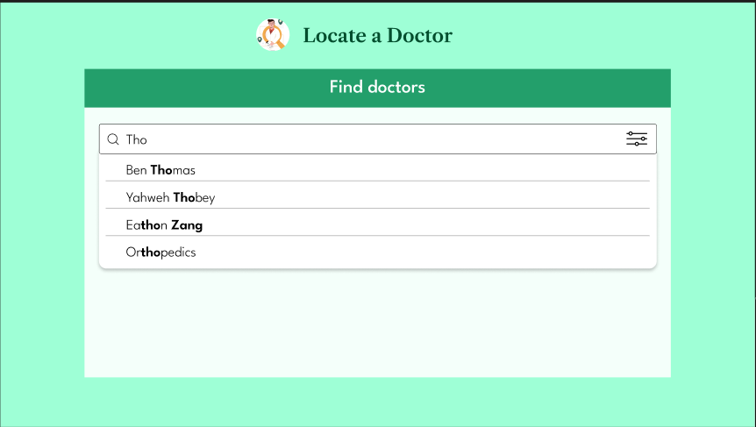
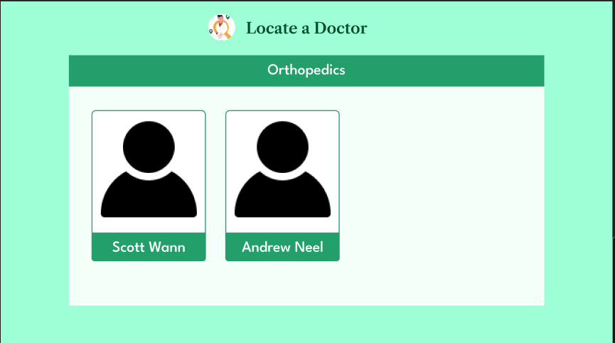

Appointment Booking
This page is used by the patient to schedule an appointment based on his requirements. The images below show how the actual appointment booking will be done from beginning to end.
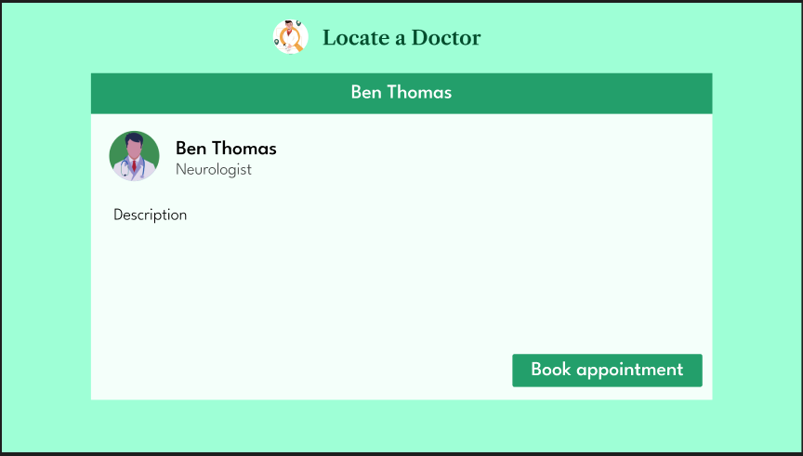
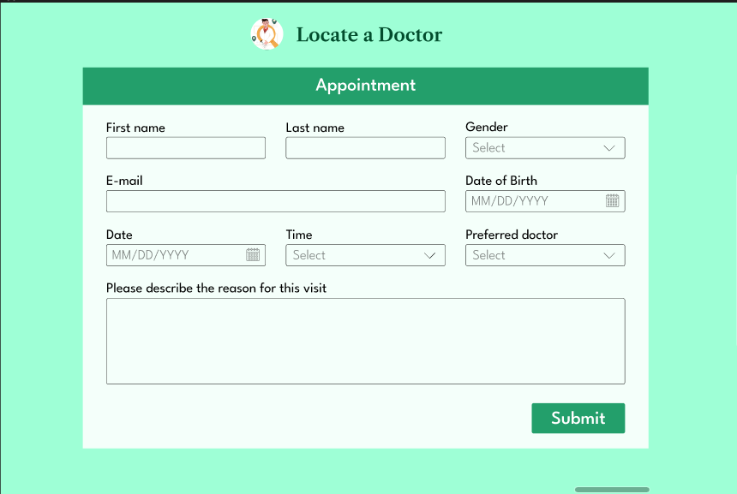
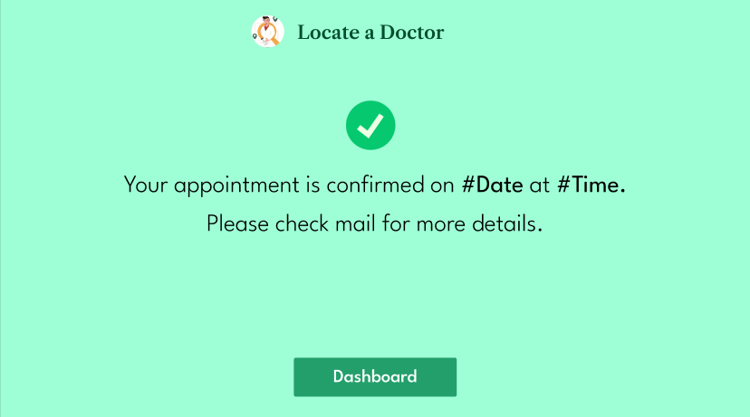

Appointment Rescheduling
This page is used by both patients and doctors to manage previously scheduled appointments.
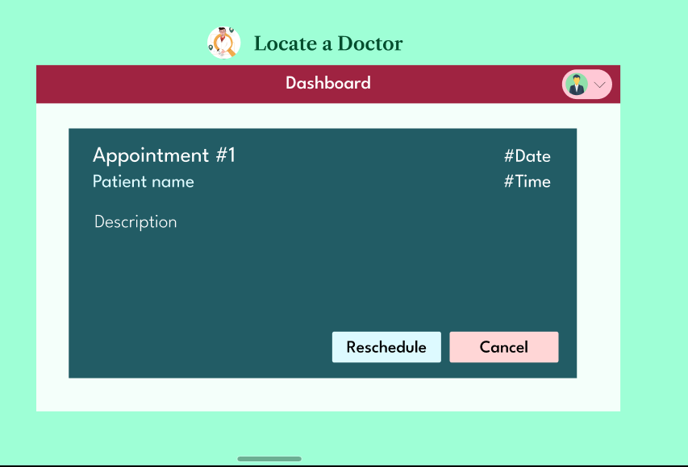

Listing Appointments
This page is used by both patients and doctors to list appointments that are relevant to them.
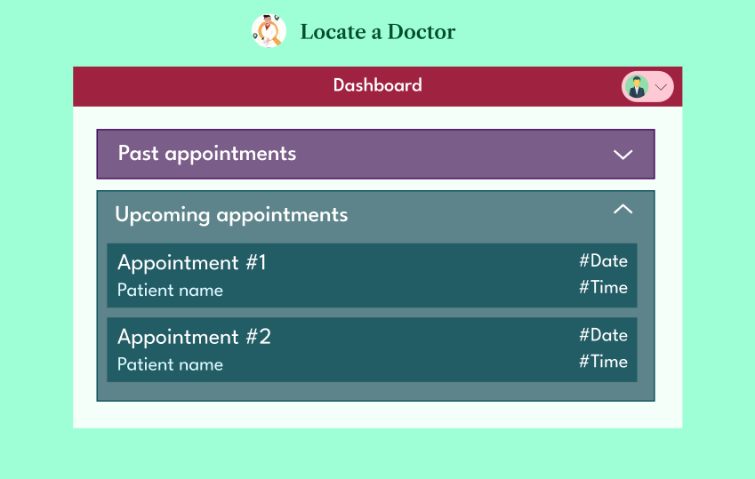

Admin Dashboard
This page is the dashboard for a logged-in admin. It will allow him to manage doctors and administrators, as well as generate patient reports and trends.
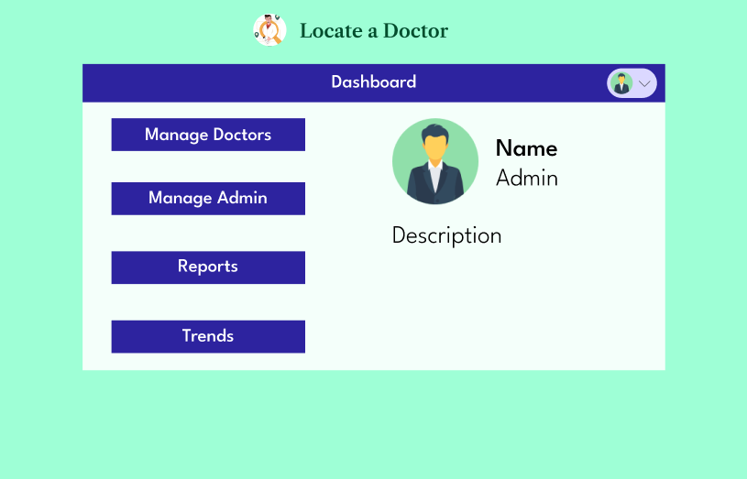

Reports generation
The following process demonstrates how the reports are generated in the locate a doctor system.
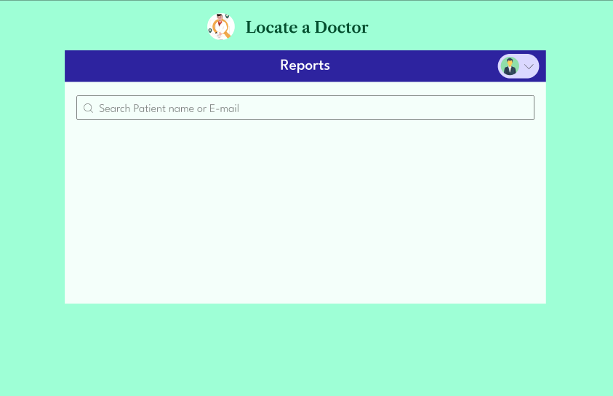
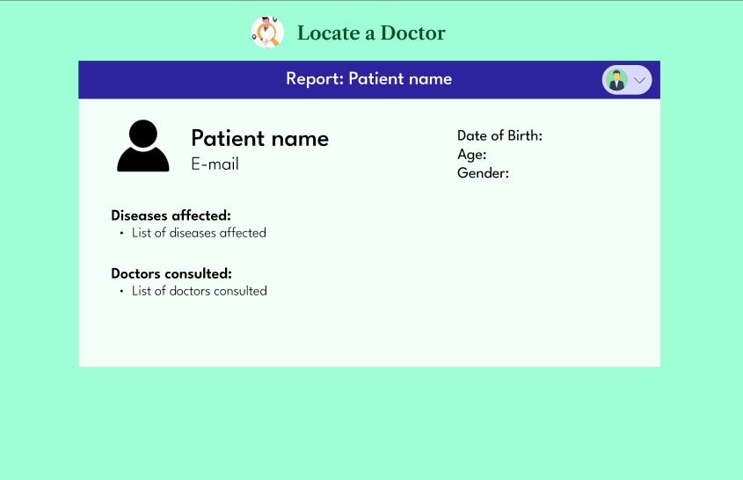

Trend Analysis
The image below shows the evaluation of trends in the locate a doctor system.
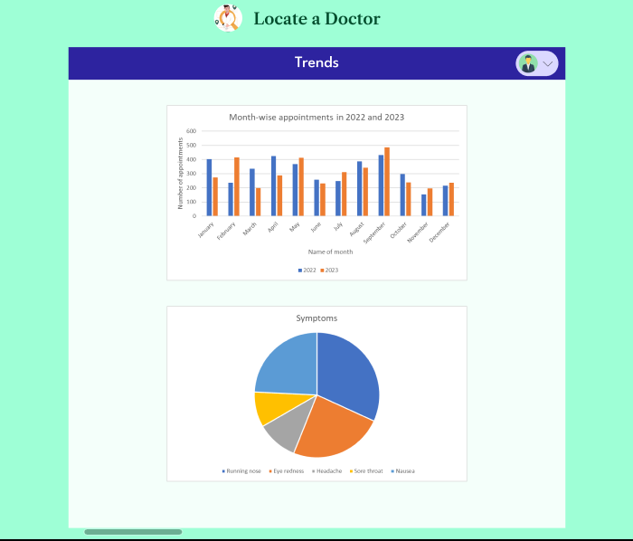

Feedback
This page is used to rate the doctor after the appointment.
